Contents

Introduction 1

Prerequisites 2

Initial Steps 2

Login to Windows Azure Management Portal 2

Windows Azure Management Portal 3

Creating a WordPress Website Service 3

Create a New Website from Gallery 3

Choose WordPress Web App 4

Configure Web Site 4

Configure Database 5

Web Site Deployment 5

Configure Your WordPress Site 5

Navigate To Your WordPress Site 5

Setup WordPress 5

Login to WordPress 6

WordPress Dashboard 6

# Introduction

The purpose of this document is to show the attendee how to set up a WordPress blog using Windows Azure Websites and gallery images.

The gallery makes available a wide range of popular web applications developed by Microsoft, third party companies, and open source software initiatives. Web applications created from the gallery do not require installation of any software other than the browser used to connect to the Windows Azure Management Portal. In this tutorial, you'll learn:

* How to create a new site through the gallery.
* How to deploy the site through the Windows Azure Portal.

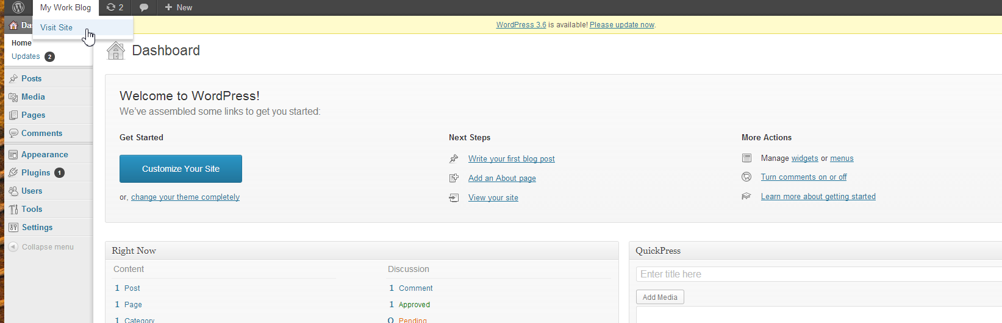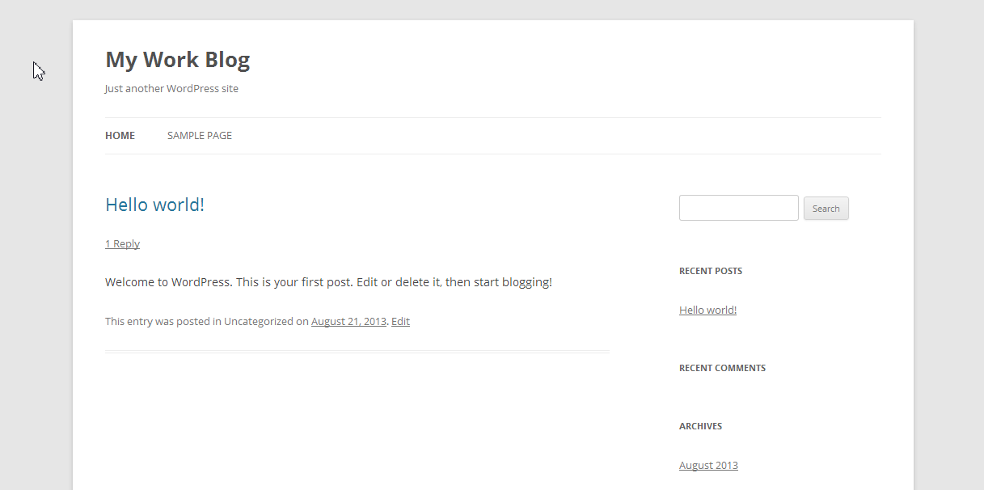You'll build a Word press blog that uses a default template. The following illustrations shows the completed application (user frontend and administration backend):

## Prerequisites

To complete this tutorial, you need a Windows Azure Account

# Initial Steps

## Login to Windows Azure Management Portal

At first, you need to login to Windows Azure. Navigate your browser to [manage.windowsazure.com](https://manage.windowsazure.com) and enter your credentials:

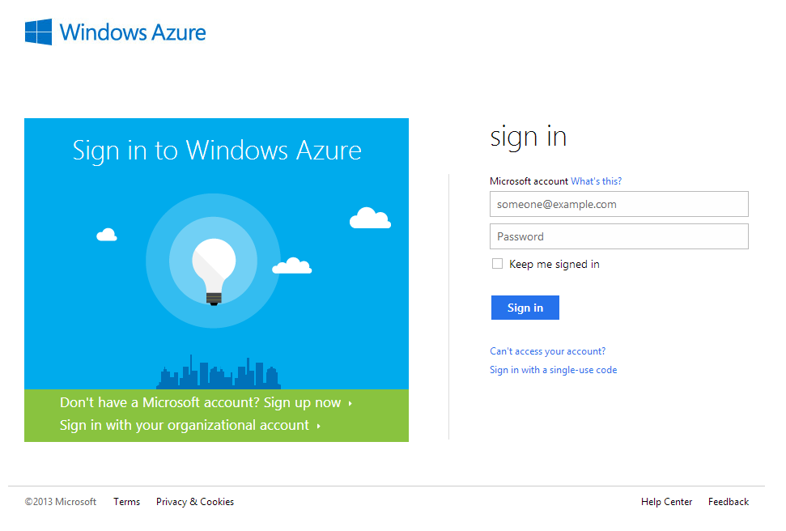

## Windows Azure Management Portal

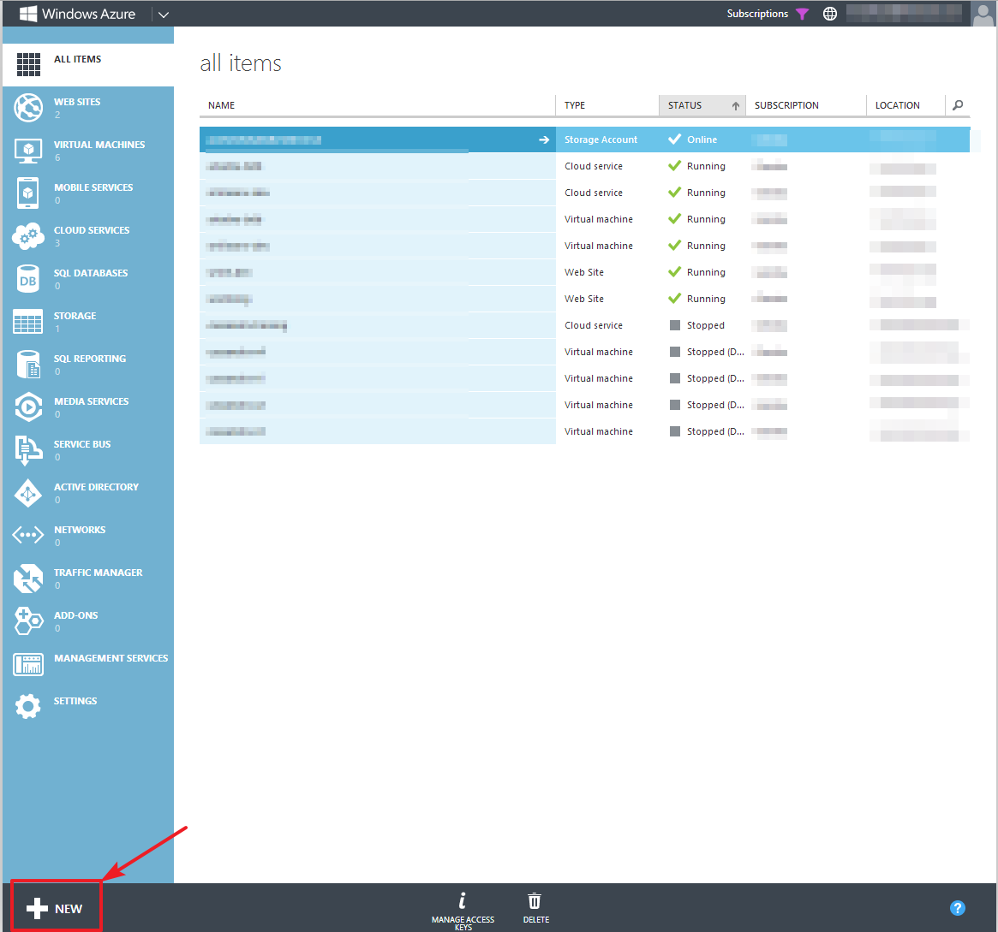After logging in, you will see the management dashboard of Windows Azure. It should list all of your cloud services (if you have any). In the bottom left corner, you will find the “New” button that allows you to create new Azure services:

# Creating a WordPress Website Service

## Create a New Website from Gallery

Navigate to the “New” button in the bottom left corner and click it:

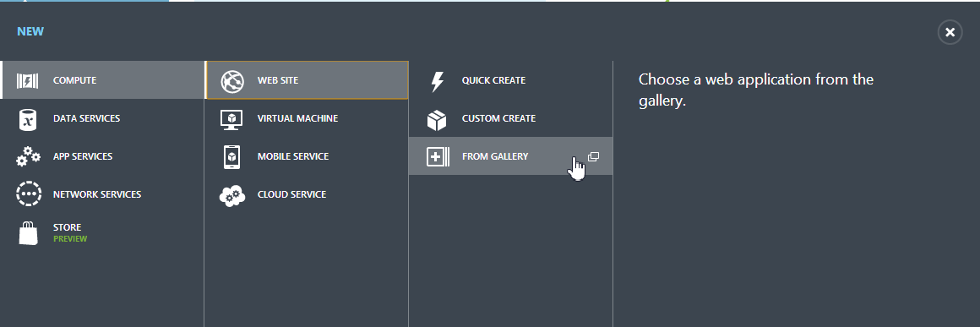C:\Users\Gernot\Documents\projects\elastacloud\msr-courseware\repo\2. Getting Started with Virtual Machines and Websites\screenshots\a - create wordpress site\02 new button.pngThe appearing window allows you to select the Azure service you want to create. Choose Compute >> Web Site >> From Gallery as in the screenshot below:

## Choose WordPress Web App

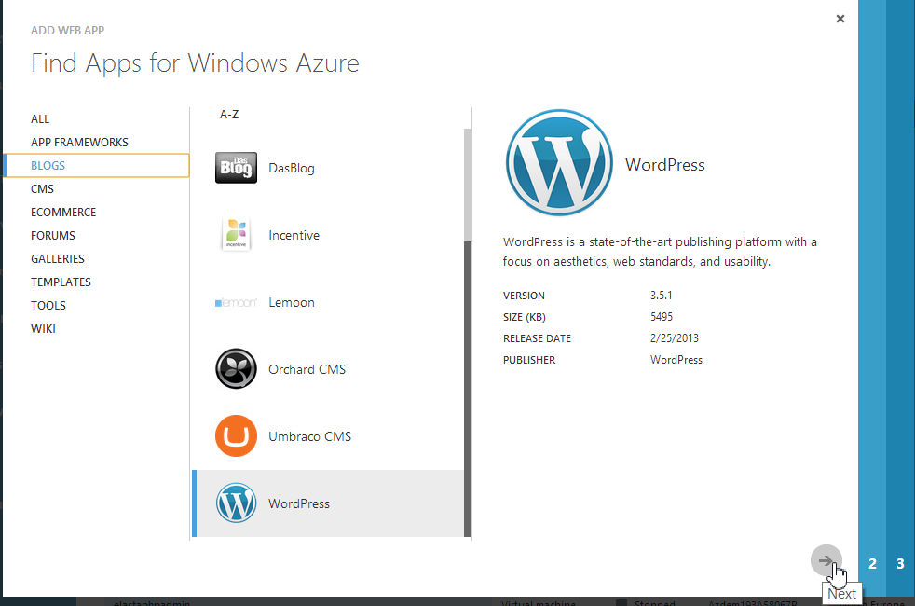A popup window will appear containing a wizard that allows you to configure your new web app. In this window, choose Blogs >> WordPress. Afterwards, click on the arrow in the bottom right corner of the Window to continue:

## Configure Web Site

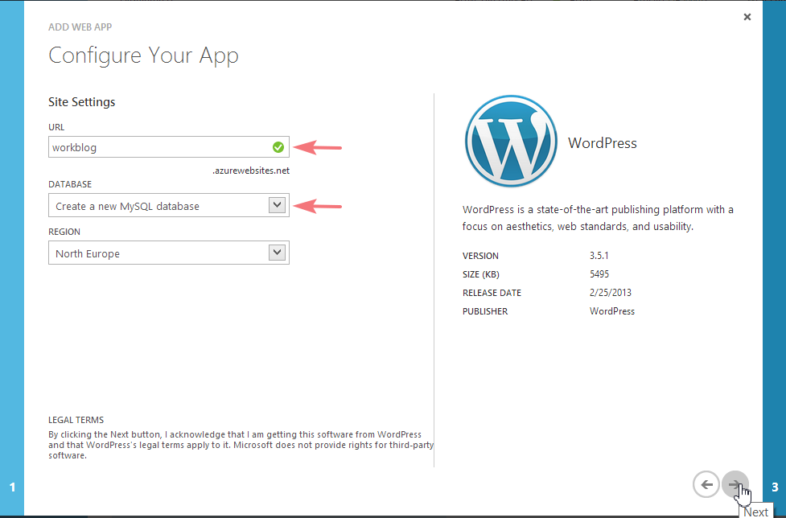On the next screen, you can configure your new WordPress app. Enter a URL name of your chose. Leave “Create a new MySQL database” selected and choose a region close to you/your target audience. Then continue with the wizard:

## Configure Database

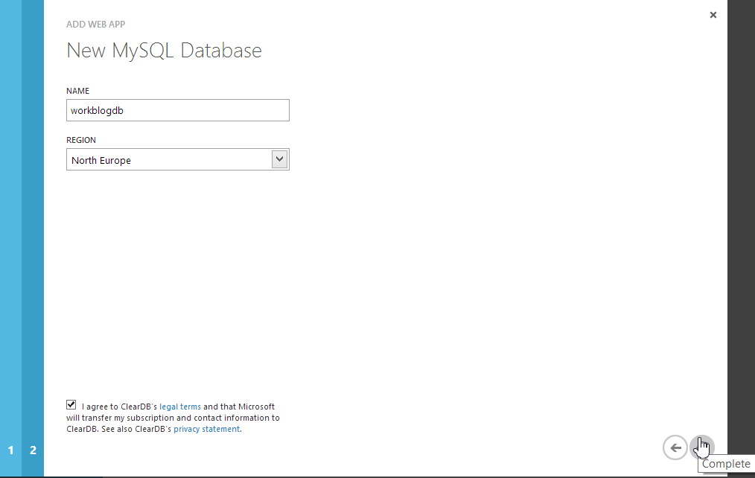On the next page, you can specify a name for your database. The database will store all the dynamic content (blog posts, comments) of your WordPress blog. You can also leave the default name if you want to. You should choose the same region as in the app configuration on the previous screen. Select the box at the bottom of the screen to agree to ClearDB's usage terms for your hosted MySQL database. Then click the check to complete the site creation:

## Web Site Deployment

After you click the “Complete” button, Windows Azure will deploy your web site. This can take a short time. You can find the progress at the bottom of the Azure Management Dashboard. You will be notified if the deployment is completed:

# Configure Your WordPress Site

## Navigate To Your WordPress Site

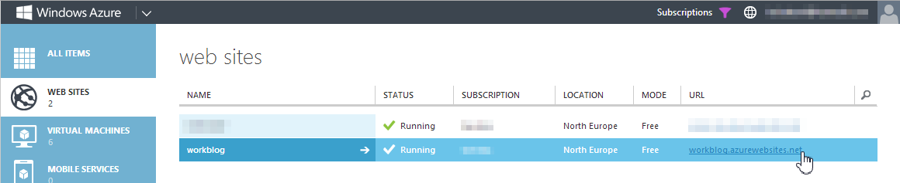After creating the web site, you will need to navigate to your WordPress site in order to configure it for the first time. Use the URL you defined earlier to access it. In case you have forgotten the URL, you can easily find it by choosing “Web Sites” in the bar on the left:

## Setup WordPress

You will need to perform an initial configuration of your WordPress site. Enter the site title, a username, a password as well as your e-mail address. Note that you can always change this information later. After entering all the information, click on the Install WordPress button:

## C:\Users\Gernot\Documents\projects\elastacloud\msr-courseware\repo\2. Getting Started with Virtual Machines and Websites\screenshots\a - create wordpress site\09 setup wordpress.pngLogin to WordPress

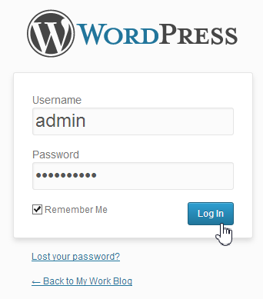The installation procedure should finish rather quickly. You will be prompted to login to WordPress. Use the user name and password you provided in the previous step:

## WordPress Dashboard

You will be forwarded to the WordPress dashboard, the place where you can administer your blog, change the theme and write new blog posts. In the menu bar at the top, you can also choose to visit your site – this will be the site your readers will see: